# **40. SNMP (Simple Network Management Protocol)**

## **SNMP Overview**

* SNMP is an **industry-standard framework and protocol** originally released in **1988**.
* Despite the word "Simple" in its name, **SNMP is powerful** and can:
  + Monitor the **status of devices**
  + Make **configuration changes**

### **SNMPv1 RFCs (Not required to memorize):**

RFC 1065 - Structure and identification of management information for TCP/IP based internets

RFC 1066 - Management information base for network management of TCP/IP based internets

RFC 1067 - A simple network management protocol

### **SNMP Device Types**

1. **Managed Devices**
   * Devices being managed using SNMP.
   * **Examples**: Routers, Switches.
2. **Network Management Station (NMS)**
   * Device(s) managing the managed devices.
   * **This is the SNMP "server".**

## 

## 

## 

## 

## 

## **SNMP Operations**

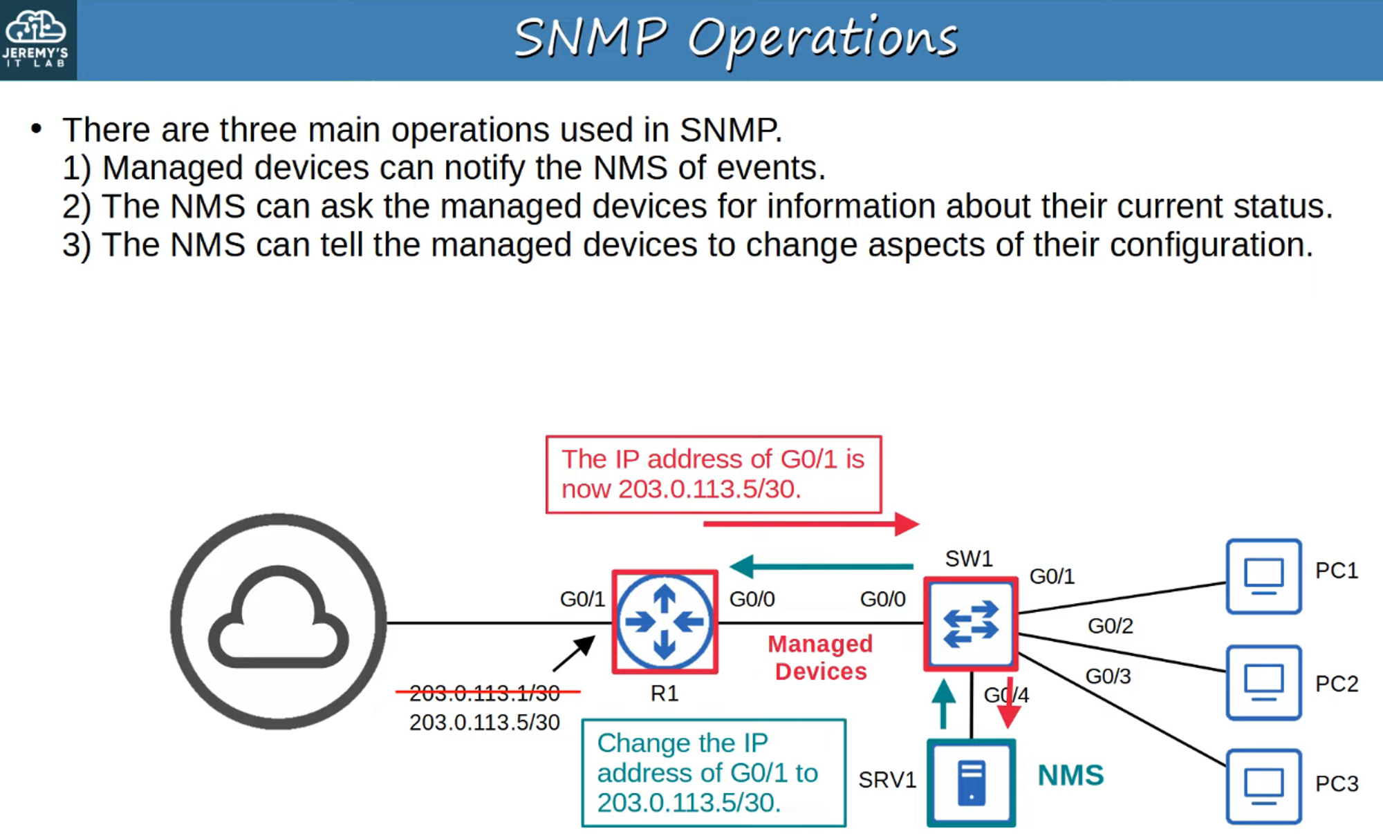

## 

## 

## 

## 

## 

## 

## 

## 

## **SNMP Components**

### **Overview**

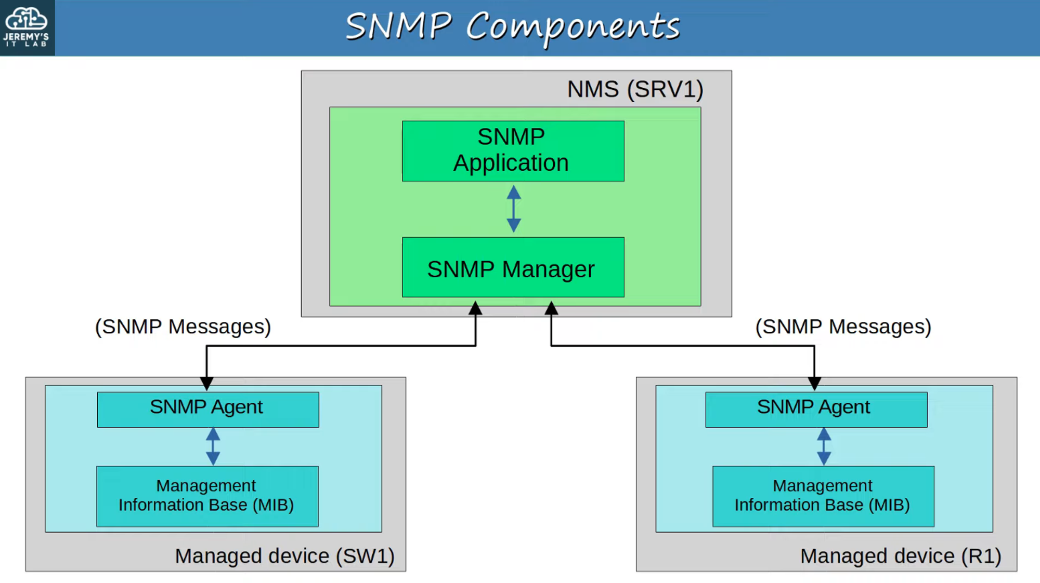

### **Network Management Station (NMS)**

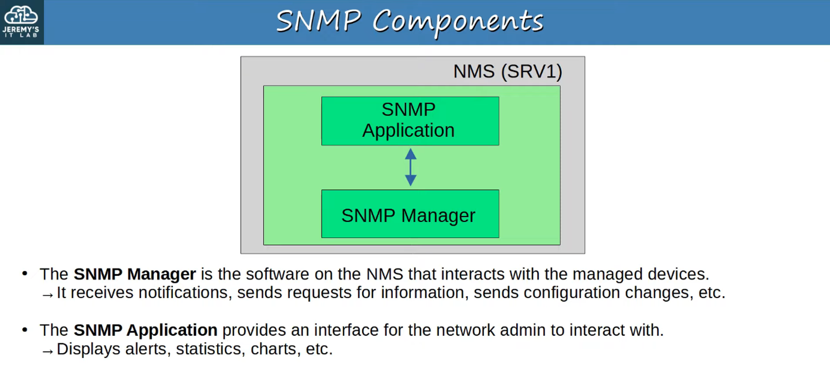

### **Managed Devices**

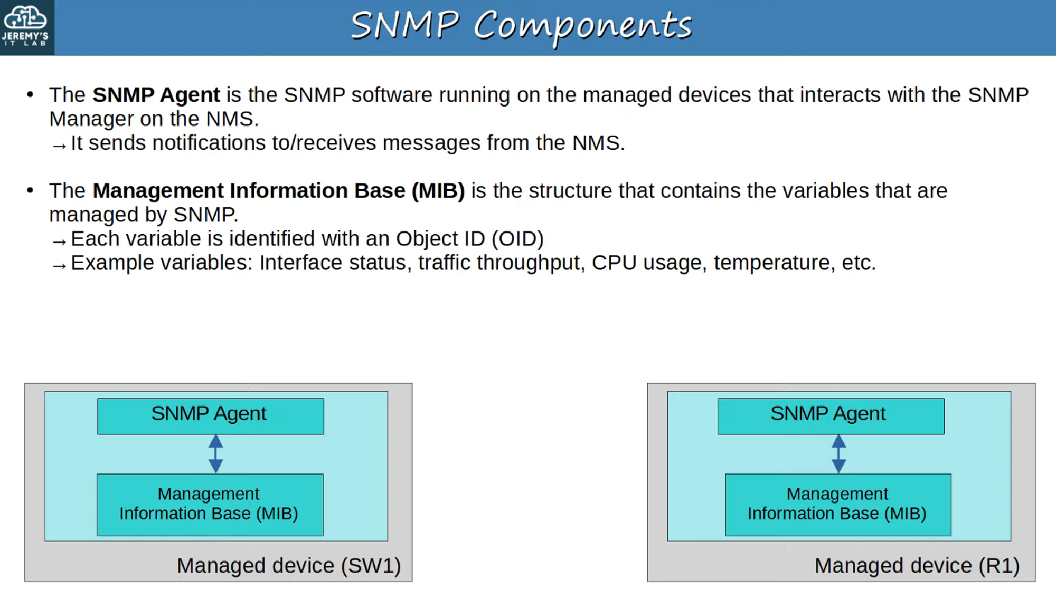

### **SNMP OIDs (Object Identifiers)**

* SNMP **Object IDs (OIDs)** are structured **hierarchically**.  
   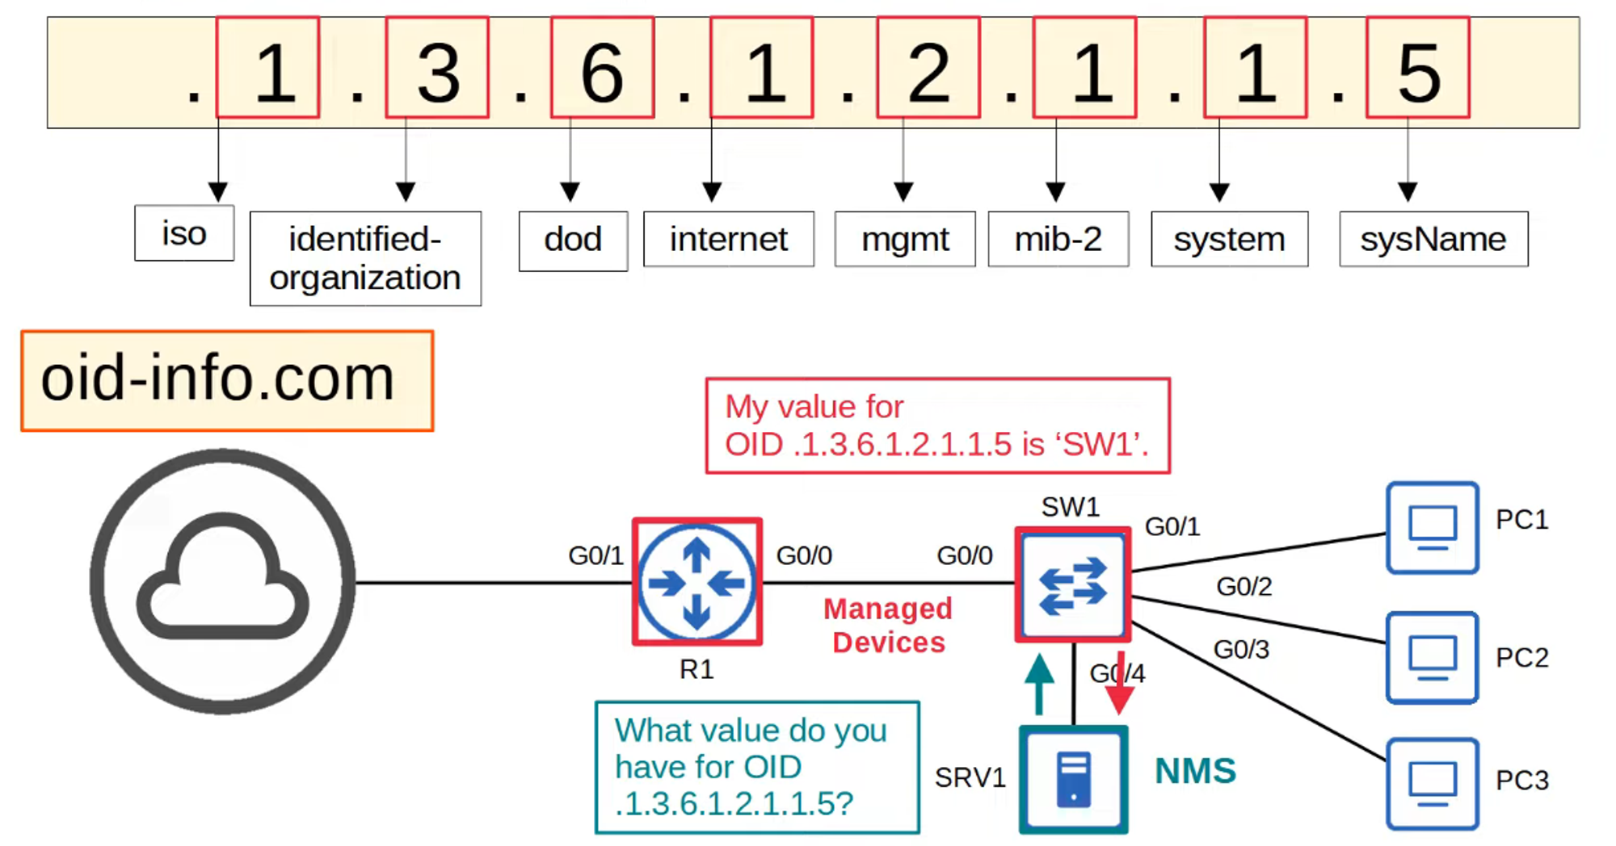

## **SNMP Versions**

Three major SNMP versions have achieved widespread use:

1. **SNMPv1**
   * The **original** SNMP version.
2. **SNMPv2c**
   * More **efficient**, allows retrieving large amounts of data in a **single request**.
   * The **"c"** stands for **"community strings"**, used as passwords.
3. **SNMPv3**
   * **Most secure** SNMP version, supports **strong encryption and authentication**.
   * 💡 **Whenever possible, SNMPv3 should be used!**

## **SNMP Messages**

### **SNMP Message Types**

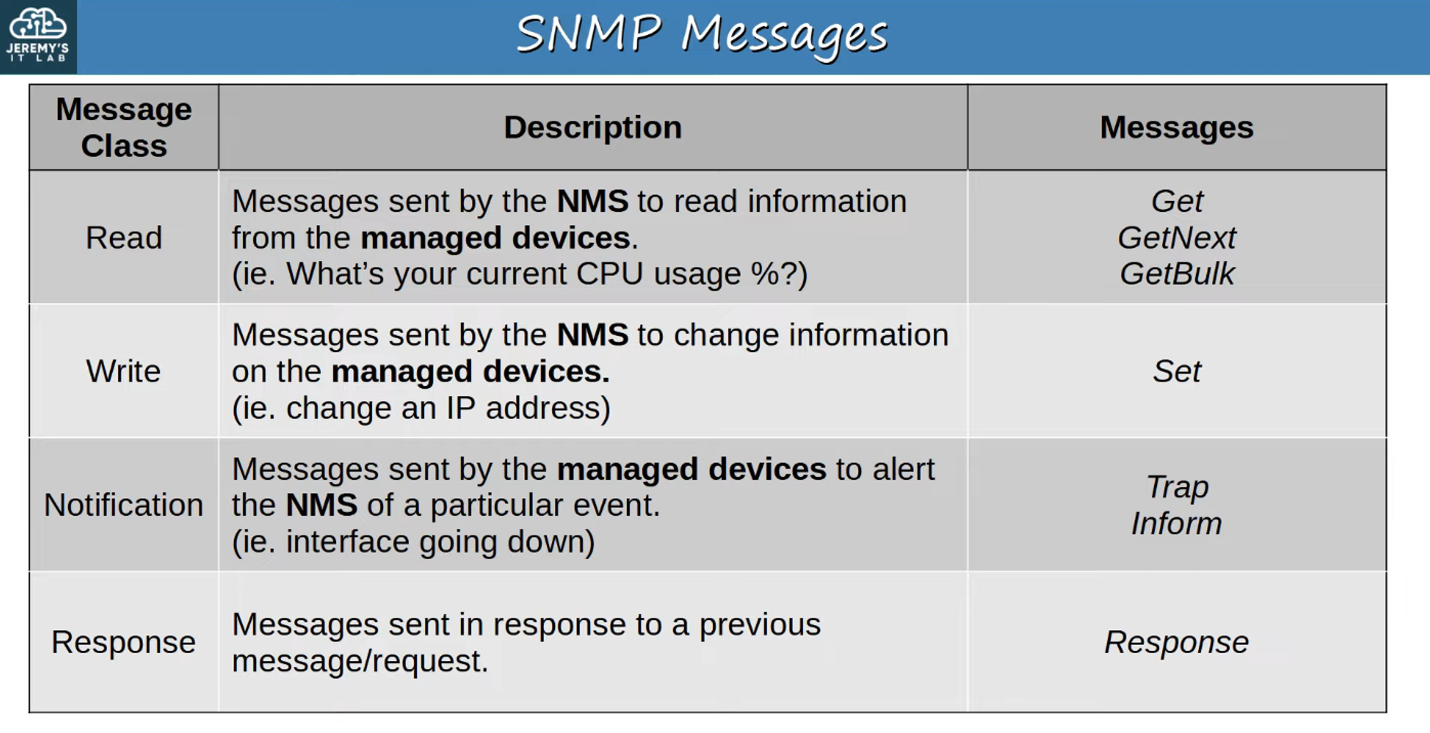

1. **SNMP Read** 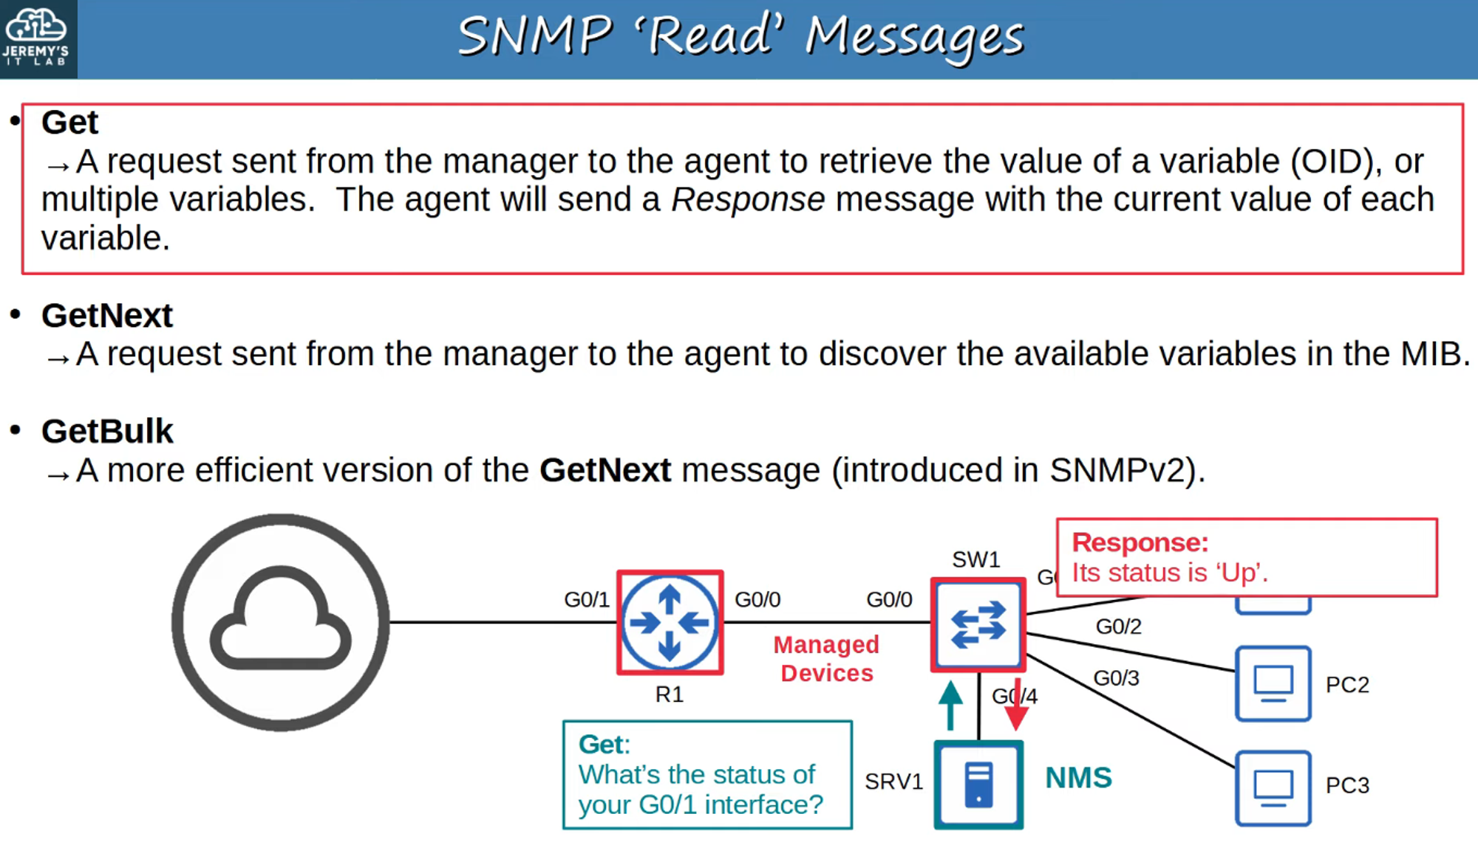
2. **SNMP Write** 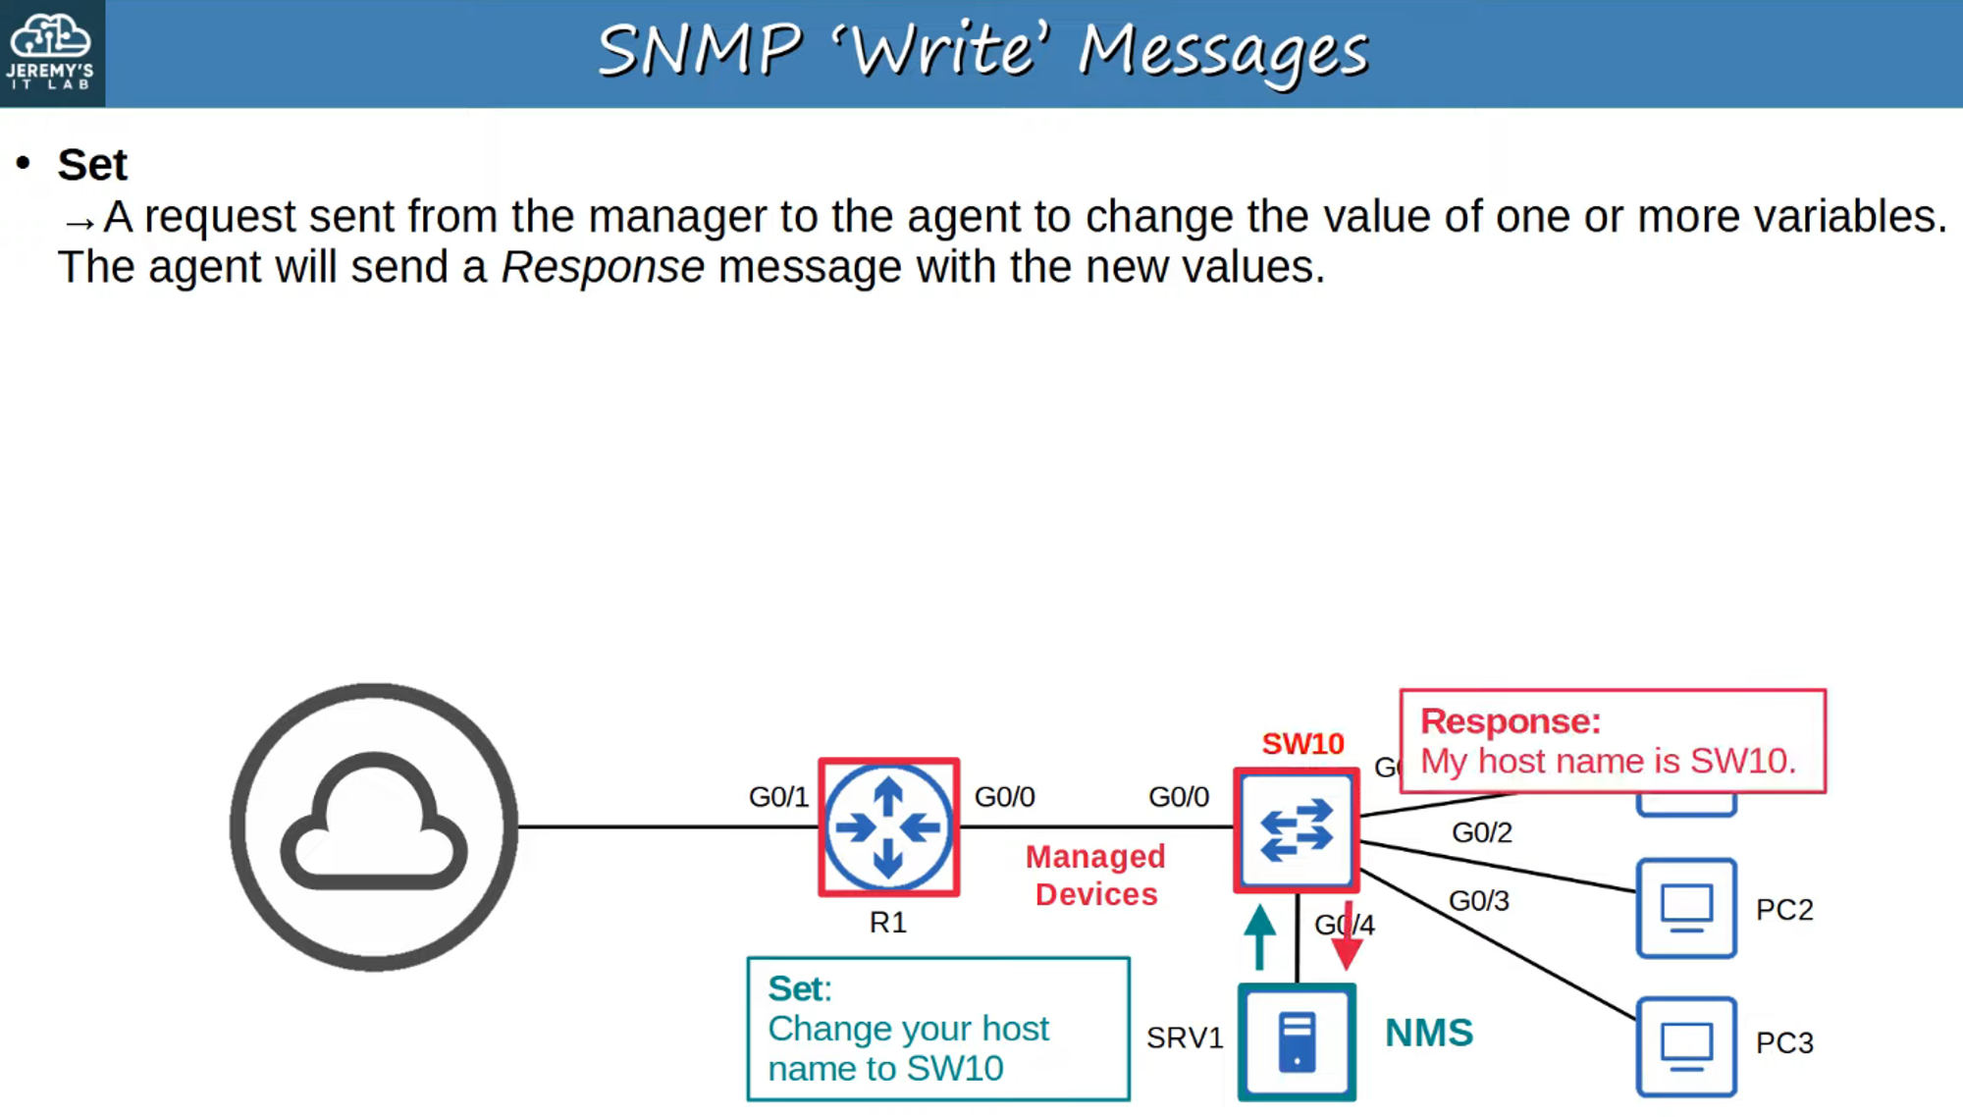
3. **SNMP Notification** 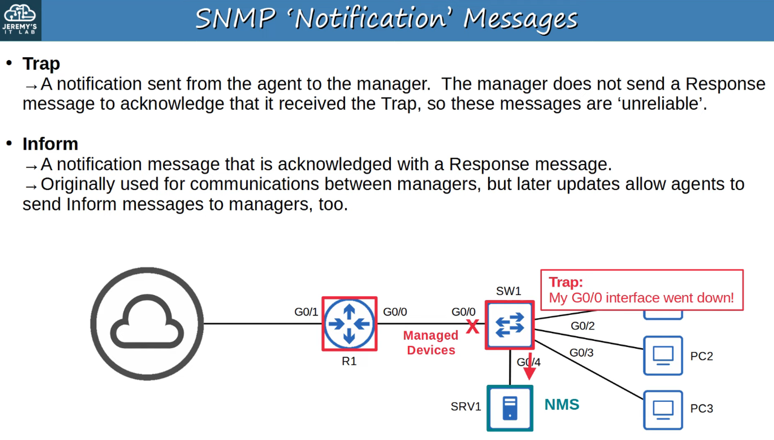

### **SNMP Communication Ports**

* **SNMP Agent** listens on **UDP Port 161**
* **SNMP Manager** listens on **UDP Port 162** 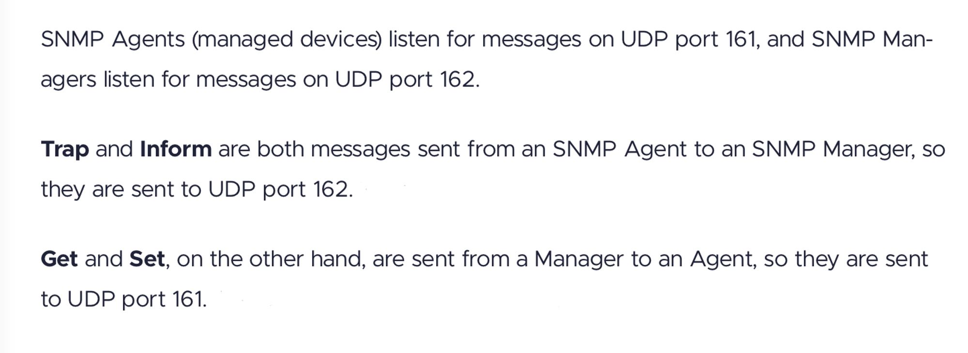

## **SNMPv2c Configuration (Basic)**

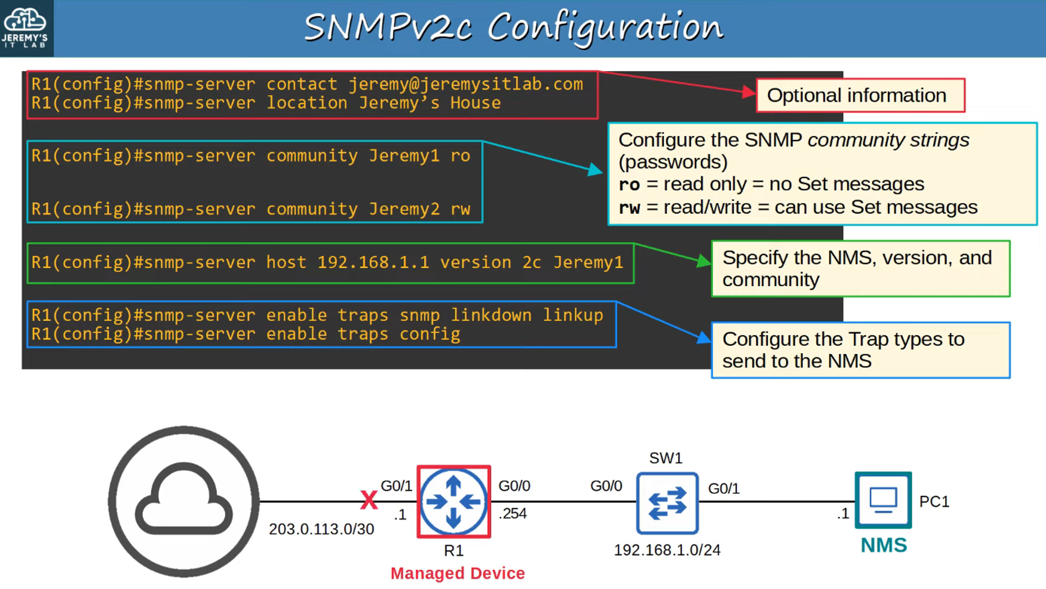

### **What Happens When R1’s G0/1 Interface Goes Down?**

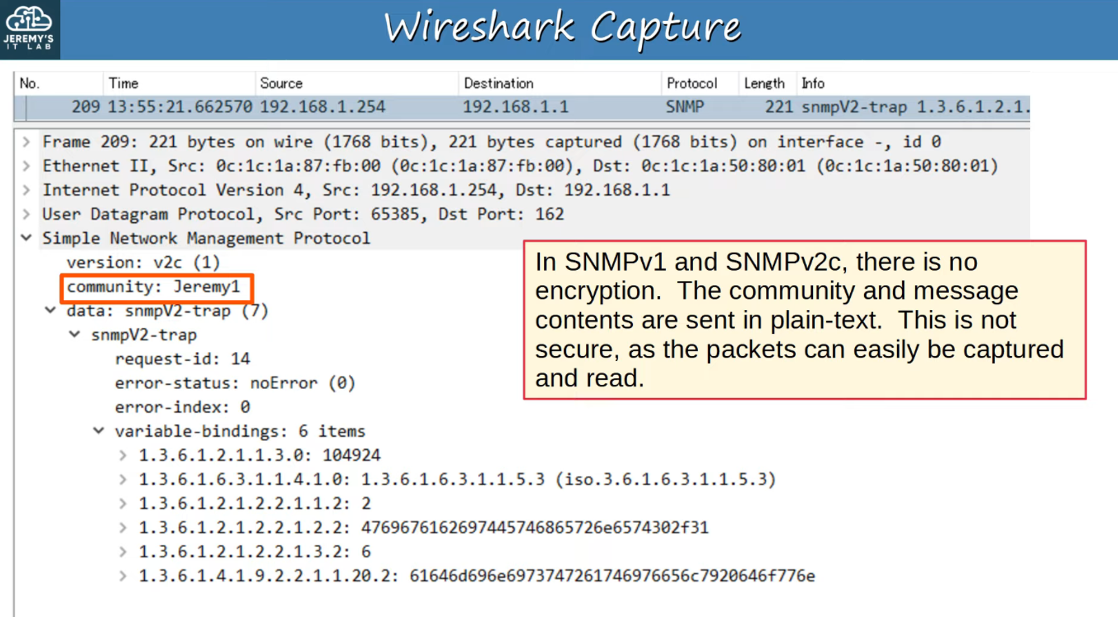

* A **UDP message** is sent to **Destination Port 162 (SNMP Manager)**.
* SNMP **version** is set to **v2c**.
* **Community string**: "Jeremy1" (Read-Only, no Set messages).
* **snmpV2-trap**: A trap message is sent due to **interface G0/1 going down**.
* **Variable bindings**: Contains the **OID identifying the issue**.

## **SNMP Summary**

* **SNMP manages devices over a network.**
* **Managed Devices** = Devices being managed (**routers, switches, firewalls**).
* **Network Management Stations (NMS)** = SNMP "servers" managing the devices.
  + NMS receives **notifications** from Managed Devices.
  + NMS can **change settings** on Managed Devices.
  + NMS can **check device status**.
* **Variables** (e.g., Interface Status, Temperature, Traffic Load) are stored in the **Management Information Base (MIB)** and identified using **Object IDs (OIDs)**.

### **SNMP Versions**

* **SNMPv1**
* **SNMPv2c**
* **SNMPv3** (💡 **Recommended for security**).

### **SNMP Message Types**

* Get / GetNext / GetBulk

* Set

* Trap

* Inform

* Response